REPORT

Abstract
Ransomware attacks blackmail victims into paying a ransom either by locking their devices and demanding a particular info in return or by encrypting the files of the user. Ransomware attacks prove to be a major threat to network securities. This report consists of experimental results obtained from four different Datasets that predict if a sample is benign or a Ransomware.. Family wise Classification of the respective Ransomware are also performed. The four Datasets are:
- Ransomware Pe Header Feature Dataset
- UGRansomeware Dataset
- CIC-Android Malware 2017 Dataset
- Riss Dataset

Majorly used ML Models are:
- Random Forest: Is a efficient ensemble method that builds multiple decision trees and merges their results for better accuracy and to reduce overfitting. We have used it for classification tasks in this experimentation.

- CatBoost: A gradient boosting algorithm that handles categorical and binary data (0's and 1's) efficiently with less preprocessing. It's highly accurate and since the datasets such as the RISS Dataset have large number of features (Columns) can be helpful.

- Support Vector Machine (SVM): SVMs find the optimal hyperplane that separates data into different classes. Works best when there's high-dimensional data and is effective in both linear and non-linear classification tasks.

- Logistic Regression: We used LR in all the datasets to find how well it works compared to other models. It predicts probabilities and is useful when the relationship between features and the target is linear.

- K-Nearest Neighbors (KNN): A method that classifies data points based on the majority class of their closest neighbors. It is time consuming, used in some of the datsets.

- XGBoost: It is a gradient boosting algorithm that works by building sequential models to correct the errors of previous models.
Generalized Block Diagram:
Train & Test Model
Analyze Data
Data Preparation
Data Wrangling
Datasets

Ransomware Pe Header Feature Dataset
Description
The dataset consists of 2157 binary executable files, including 1134 legitimate software samples (referred to as Goodware) and 1023 ransomware samples, which are further classified into 25 distinct ransomware families. The data extracted from each file comprises the first 1024 bytes of the Portable Executable (PE) header. The dataset is organized in a CSV format with several columns. These include a unique Sample ID for each file, a Filename that lists executable names for goodware and the SHA-256 hash for ransomware, a Target Class (GR) where 0 represents goodware and 1 represents ransomware, a Family ID that indicates the ransomware family (0 for goodware and values between 1 to 25 for ransomware), and Numerical Columns ranging from 0 to 1023, containing raw byte values between 0 and 255.
The Goodware samples are identified by IDs ranging from 10000 to 11133, and their filenames are typical executable names. Ransomware samples, on the other hand, are identified by IDs between 20000 and 21022, and their filenames are represented by their SHA-256 hashes. Ransomware samples are also grouped by family, with family IDs ranging from 1 to 25, each corresponding to a specific ransomware family. The ransomware families include: Avaddon, Babuk, Blackmatter, Conti, Darkside, Dharma, Doppelpaymer, Exorcist, Gandcrab, Lockbit, Makop, Maze, Mountlocker, Nefilim, Netwalker, Phobos, Pysa, Ragnarok, RansomEXX, Revil, Ryuk, Stop, Thanos, Wastedlocker, and Zeppelin. Each ransomware sample is tagged with the corresponding family ID, allowing for detailed classification and analysis of the dataset.

Family Count:

ID | Family | ID | Family | ID | Family
1 | Avaddon | 12 | Maze | 23 | Thanos
2 | Babuk | 13 | Mountlocker | 24 | Wastedlocker
3 | Blackmatter | 14 | Nefilim | 25 | Zeppelin
4 | Conti | 15 | Netwalker
5 | Darkside | 16 | Phobos
6 | Dharma | 17 | Pysa
7 | Doppelpalymer | 18 | Ragnarok
8 | Exorcist | 19 | RansomeXX
9 | Gandcrab | 20 | Revil
10 | Lockbit | 21 | Ryuk
11 | Makop | 22 | Stop

Methodology-1(Multiclass):
We used Random Forest to select the most relevant features from the dataset, applying a threshold of 0.0007 to filter out less important ones. This reduced the number of features from 1,024 to 401, making the model easier to interpret and faster to run.
Analysing the confusion matrix, the Random Forest model showed strong classification abilities, especially in correctly identifying benign samples. The low rate of false alarms (false positives) indicates that the model is reliable in distinguishing between benign and malicious cases.

Block Diagram-
Performance Analysis of Ransomware PE headers Results (Multiclass)-1:[1]
Model | Accuracy | Precision | F1-Scrore | Recall
KNN | 0.86 | 0.85 | 0.85 | 0.86
SVM | 0.85 | 0.85 | 0.82 | 0.81
Decision Tree | 0.87 | 0.86 | 0.87 | 0.87
Random Forest | 0.92 | 0.92 | 0.91 | 0.92
Naive Bayes (Gaussian-NB) | 0.55 | 0.84 | 0.61 | 0.55

Confusion Matrix:
(Random Forest):

Methodology-2:
Feature Selection method used in this methodology is Principal Component Analysis [PCA]. The method maps the m features in the dataset[m=1023] to reduce no of features n. We used a trial and test method to find the best number for n. The numbers were in an interval of 100 from 100 to 1000. The best fit for n was 400.We have tried for both binary and family classification. For binary it is benign or ransomware. For Family only the ransomware samples are taken, and the 25 families are classified.

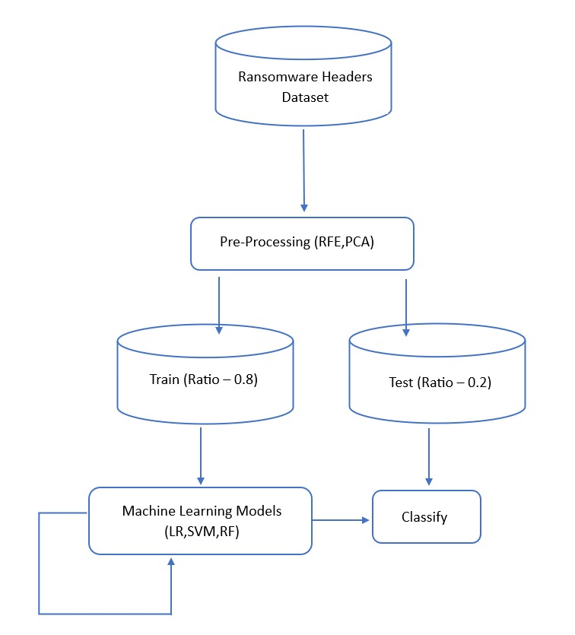

Binary:
Performance Analysis of Ransomware PE headers Without Feature Reduction:
Model | Accuracy | Precision | F1score | Recall
Random Forest | .9293 | .9035 | .9238 | .9450
SVC | .91599 | .9120 | .9115 | .9109
Logistic Regression | .9048 | .9157 | .9014 | .8875

Performance Analysis of Ransomware PE headers With Feature Reduction:[2]
Model | Accuracy | Precision | F1score | Recall | Benchmark
 |  |  |  |  | Accuracy | Precision | F1 Score | Recall
Random Forest | .8957,.9264 | .8095,.8986 | .8804,.9205 | .9650,.9435 | 0.96 | 0.95 | 0.96 | 0.97
SVC | .9148 | .8986 | .9092 | .92 | 0.96 | 0.95 | 0.96 | 0.96
Logistic Regression | .9109 | .9365 | .9082 | .8816 | 0.94 | 0.94 | 0.94 | 0.94
*PCA [ n = 400]
*RFE [n = 1000]

Random Forest [ n_estimators=400, min_samples_split=5, min_samples_leaf=2, max_features='log2', max_depth =182, bootstrap=False]
SVC [ C=1e-06, gamma=0.001, kernel='poly']

Multiclass:
Performance Analysis of Ransomware PE headers Without Feature Reduction:
Model | Accuracy | Precision | F1score | Recall
Random Forest | .9293 | .9035 | .9238 | .9450
SVC | .91599 | .9120 | .9115 | .9109

Performance Analysis of Ransomware PE headers With Feature Reduction:
Model | Accuracy | Precision | F1score | Recall
Random Forest | .8684*, .7850** | .7049*, .5289** | .7676*, .6346** | .9385*, .9888
SVC | .7949** | .537** | .6050** | .8315**

*Reduced Feature Extraction [ n = 300], **PCA [n = 400]
Random Forest [ n_estimators=400, min_samples_split=5, min_samples_leaf=2, max_features='log2', max_depth =182, bootstrap=False]
SVC [ C=1e-06, gamma=0.001, kernel='poly']

Ugransomware Dataset
Dataset Description:
The dataset is the UGRansome dataset, created in 2021. This dataset is designed specifically for detecting zero-day and ransomware attacks, focusing on anomalies that traditional threat signatures may not identify. It includes both normal and abnormal network traffic, capturing patterns that are crucial for identifying Advanced Persistent Threats (APT) such as Razy, Globe, EDA2, and TowerWeb.
The UGRansome dataset integrates data from real-world sources like UGR '16 and ransomware behavior, making it highly effective for detecting evolving threats in network security. The dataset consists of 149,043 data points across 14 attributes, including various attack types such as DoS, Botnet, Spam, UDP Scan, and Port Scanning.

Block Diagram
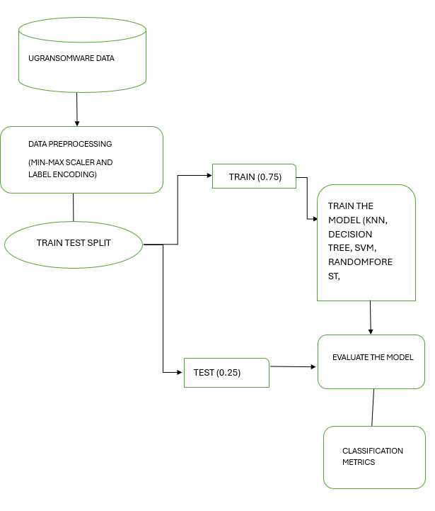

Family Count:

S.No | Family | Count
1  2  3  4  5  6  7  8  9  10  11  12  13  14  15  16  17 | Locky  SamSam  WannaCry  JigSaw  Flyper  DMALocker  APT  CryptXXX  Razy  Globe  EDA2  TowerWeb  Cryptohitman  NoobCrypt  CryptoLocker  CryptoLocker2015  Globev3 | 25062  19657  16110  13712  12014  11360  9730  9335  7862  7373  6054  4381  4134  1248  788  150  73

Methodology-1 (Binary Classification):
The dataset has been divided into training and testing sets. Since both the number of samples and the number of features is limited, dimensionality reduction and feature selection techniques were not applied.
The models, including K-Nearest Neighbors (KNN), Naive Bayes, Decision Tree Classifier, and Random Forest Classifier, were trained using the training dataset. The accuracy for each model was then evaluated and printed using the test dataset. From the table random forest achieved high accuracy and high precision value.
Performance Analysis of UGRansomeware Results 1: [4]
Model | Accuracy | Precision | F1-Scrore | Recall | Benchmark (Accuracy)
KNN | 0.97 | 0.97 | 0.97 | 0.97 | NIL
SVM(SVC) | 0.91 | 0.91 | 0.92 | 0.92 | 0.69
DECISION TREE | 0.98 | 0.98 | 0.98 | 0.98 | NIL
RANDOM FOREST | 0.98 | 0.97 | 0.97 | 0.97 | 1
NAIVE BAYES (GAUSSIAN-NB) | 0.72 | 0.73 | 0.71 | 0.72 | 0.78
Methodology –2(Multiclass):
- Divide the data into training and testing sets as usual.
- Balance the training set using an oversampling method This creates more examples for the smaller class so that it's more balanced.
- Train your models (KNN, Naive Bayes, Decision Tree, Random Forest) using the balanced training set.
- Test the models on the original test set (without oversampling) and print their accuracy.

Performance Analysis of UGRansomeware Results 2:[4]
Model | Accuracy | Precision | F1-Scrore | Recall
KNN | 0.61 | 0.60 | 0.60 | 0.61
SVM | NIL | NIL | NIL | NIL
Decision Tree | 0.63 | 0.62 | 0.61 | 0.63
Random Forest | 0.63 | 0.61 | 0.61 | 0.63
Naive Bayes (Gaussian-NB) | 0.31 | 0.28 | 0.25 | 0.31

CIC-ANDMAL –2017(Benign Vs Ransomware):
The data has a total of 10,854 samples, including 4,354 malware and 6,500 benign applications from various sources. Over six thousand benign apps were sourced from the Google Play Store for the years 2015, 2016, and 2017. From these, 5,000 samples (426 malware and 5,065 benign) were installed on real devices. Our CICAndMal2017 dataset classifies the malware into four categories: Adware, Ransomware, Scareware, and SMS Malware, with a total of 42 distinct malware families. The Adware category includes the Dowgin, Ewind, Feiwo, Gooligan, Kemoge, Koodous, Mobidash, Selfmite, Shuanet, and Youmi families, with each family contributing between 4 and 15 samples. The Ransomware category consists of the Charger, Jisut, Koler, LockerPin, Simplocker, Pletor, PornDroid, RansomBO, Svpeng, and WannaLocker families, each with 10 to 11 samples. In the Scareware category, families like AndroidDefender, AndroidSpy.277, AV for Android, AVpass, FakeApp, FakeApp.AL, FakeAV, FakeJobOffer, FakeTaoBao, Penetho, and VirusShield contributed between 6 and 17 samples. Lastly, the SMS Malware category includes the BeanBot, Biige, FakeInst, FakeMart, FakeNotify, Jifake, Mazarbot, Nandrobox, Plankton, SMSsniffer, and Zsone families, with 9 to 11 samples per family.

Block Diagram:
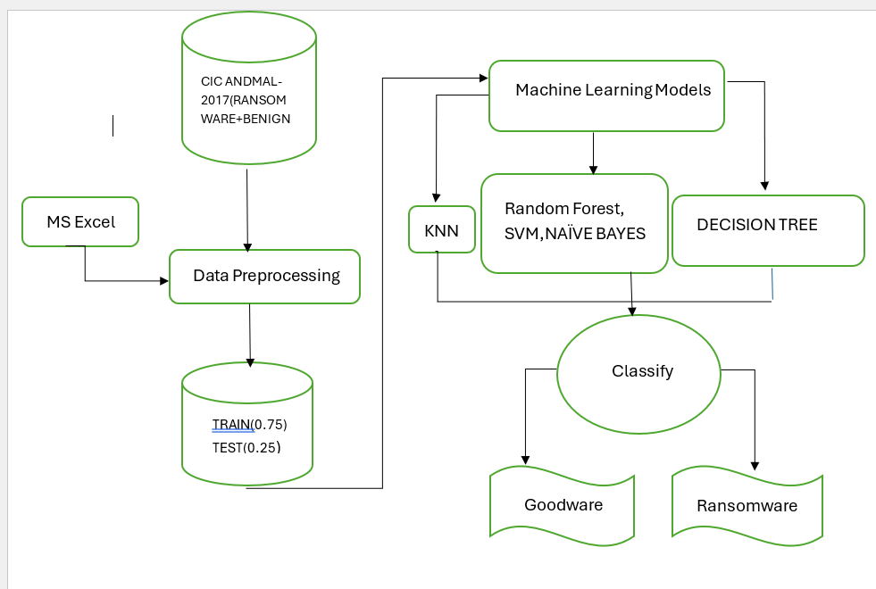

Methodology:
The Ransomware dataset was combined with the benign dataset. For feature selection, we used the variance thresholding technique, which reduced the number of features from 83 to 73. Then, a negatively correlated feature reduction technique was applied, further reducing the number of features to 30. The data was split into training and test datasets. Various classification models were used, and their classification reports were generated.

Performance Analysis of Android Malware (Multiclass)Results:
Model + Hyperparameter | Accuracy | Precision | F1-Score | Recall
KNN | 0.98 | 0.98 | 0.98 | 0.98
DECISION TREE | 0.999 | 0.999 | 0.999 | 0.999
RANDOM FOREST, n_estimators=100, random_state=42 | 0.994 | 0.994 | 0.994 | 0.994
SVC | NIL | NIL | NIL | NIL
NAIVE BAYES(GAUSSIAN NB) | 0.84 | 0.82 | 0.82 | 0.84

Confusion Matrix:

RISS Dataset
Methodology
The RISS dataset is only with binary data (0’s and 1’s) in all its fields. This makes it better with some pre-processing techniques and ML models while others may not perform as much. The goal of this work was to try out different models and techniques and check which works better when and why. Parameters were changed and hyper tuned to figure out the optimal values to ensure high accuracy.

Block Diagram
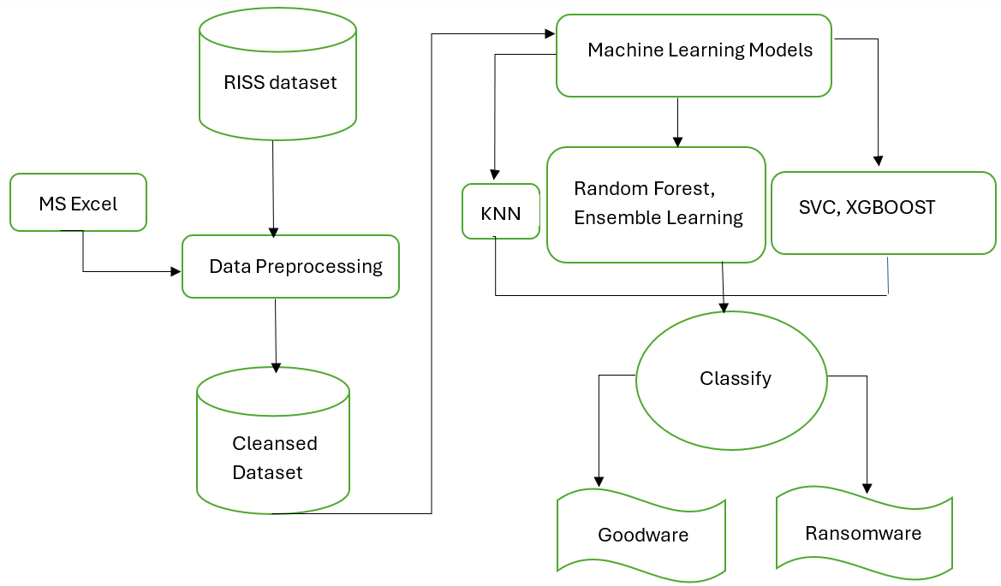

Binary Classification
80% of the dataset was used for training, while the remaining 20% was reserved for validation (testing). With random_state = 42 and n_neighbors = 5, the K-Nearest Neighbors (KNN) classifier achieved an accuracy of 0.91 in classifying whether a sample was benign software or ransomware. The Decision Tree classifier achieved an accuracy of 0.98, and the Naive Bayes model reached 0.76. Default parameter values were used for all models: KNN, Decision Tree, and Naive Bayes.

Performing Gridsearchv without feature reduction:
RFC
param_grid = {
'n_estimators': [50,100, 200],
'max_depth': [None, 10, 20],
'min_samples_split': [2, 5, 10]
}

Riss Dataset Binary Classification (Ransomware/Benign) [3]
Model | Without feature reduction |  |  |  | With feature reduction* |  |  |  | Benchmark**
Model | Accuracy | Precision | F1 score | Recall | Accuracy | Precision | F1 score | Recall | Hoeffding Trees (HT) | Random HT
KNN | 0.911 | 0.92 | 0.91 | 0.91 | - |  |  |  | 0.99 | 0.64
DST | 0.98 | 0.98 | 0.98 | 0.98 |  |  |  |  | 0.99 | 0.64
NB | 0.79 | 0.84 | 0.80 | 0.80 |  |  |  |  | 0.99 | 0.64
Random forest | 0.977 | 0.98 | 0.98 | 0.98 | 0.59* | 0.65* | 0.59* | 0.59* | 0.99 | 0.64
SVM | 0.89 | 0.91 | 0.90 | 0.90 | 0.79* | 0.82* | 0.78* | 0.79* | 0.99 | 0.64

We can observe a high accuracy of 0.98 and 0.97 from the Decision tree algorithm and the Random Forest model respectively. Default values were used for the parameters. DecisionTreeClassifier() and RandomForestClassifier(n_estimators = 100, random_state= 42)
*umap (Uniform Manifold Approximation and projection)
n_neighbors=15, min_dist=0.1, n_components=500, random_state=42, verbose=3

**Benchmark paper uses Hoeffding Trees Classifier Algorithms in RISS dataset. (Extremely fast decision trees – 0.99 and Random Hofedding Trees – 0.64)

Hoeffding trees work well for real time stream of data such as continuous data. They are incremental learners so they build models on-the- fly. These models do not require them to store the whole dataset which is why they are considered a good choice.
The benchmark paper used to compare results has implemented the VFDT ( Very fast decision tree) and the EFDT (Extremely fast decision tree) which form the basis of hoeffding trees. EFDT is better than VFDT as it can adapt to changes in the data distribution hence giving us an increase in accuracy.

However, we notice that Random Hoeffding trees (benchmark paper) has resulted in a significant decrease in the accuracy.
Riss Dataset Multiclassification (Ransomware Family) [3]

Model | Without feature reduction |  |  |  | With feature reduction* |  |  |  | Benchmark
Model | Accuracy | Precision | F1 score | Recall | Accuracy | Precision | F1 score | Recall | -
SVC | 0.75 | 0.73 | 0.70 | 0.75 | 0.87* | 0.88 | 0.87 | 0.87 | -
RFC | 0.87 | 0.88 | 0.87 | 0.87 | 0.90* | 0.85 | 0.85 | 0.86 | -
Catboost | 0.82 | 0.84 | 0.82 | 0.83 | - |  |  |  | -
KNN | - |  |  |  | - |  |  |  | -
LR |  |  |  |  | 0.83* | 0.84 | 0.84 | 0.84 | -

*PCA (n_components = 0.95, max_iterations = 1000, random_state = 42)
Benchmark paper could not be found in the Multiclassification of the RISS dataset. From the table, we observe that with feature reduction we acheive a accuracy of 0.9 in the random forest algorithm. CatBoost is an algorithm based on Gradient Boosting. It does well with binary data classification as . SVC brings an accuracy of 0.87.
Parameters
CatBoost:
{ iterations=1000,
learning_rate=0.1,
depth=6,
eval_metric='Accuracy',
verbose=100 }
SVC:
{kernel='poly', random_state=42}

Dataset Description:
The RISS dataset was analyzed to distinguish benign and ransomware activities, with 1,524 samples, of which 942 are benign and the rest 582 were classified as ransomware. The ransomware samples are also categorized into 12 types of families, consisting of different ransomware types observed and analyzed with the help of this dataset. The Cuckoo Sandbox, an automated malware analysis system, has been utilized during the analysis of this dataset. Using this tool, several features were extracted for the dataset, which would help define benign from malicious behavior.
The 12 Ransomware families mentioned in the RISS dataset are Critroni, CryptLocker, CryptoWall, KOLLAH, Kovter, Locker, Locker, PGPCODER, Reveton, TeslaCrypt, Trojan-Ransom.
Features identified are further categorized and represented by codes:
- API: Monitors all the API calls, which are basically function calls used by programs to request services from the OS. It is a very important sign in detection of malicious action.
- DROP: Tracks the extensions of the files that ransomware drops.
- REG: Tracks the registry key operations where the ransomware may alter or tamper for persistence or modification of system configurations.
- FILES: It has a monitoring scope that follows operations about the creation, deletion, or modification of files. This is usually taken advantage of by ransomware attacks.
- FILES_EXT: Tracks extensions of files that are involved in the operation of file creation, modification, or deletion. These extensions may give hints as to which file type a ransomware attack has targeted.
- DIR: Keeps track of the operations of files from their directory because ransomware attacks primarily target certain directories for file encryption.
- STR: Retrieves and analyzes embedded strings with clues regarding a ransomware process or benign one.

Results And Discussion:
RISS (Confusion Matrices- Multiclass Tabulation):
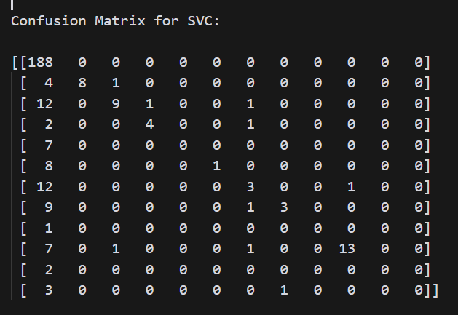
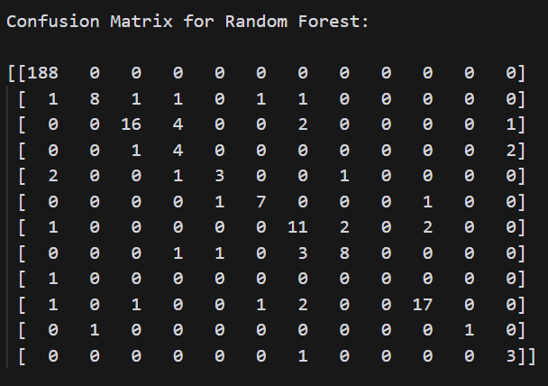
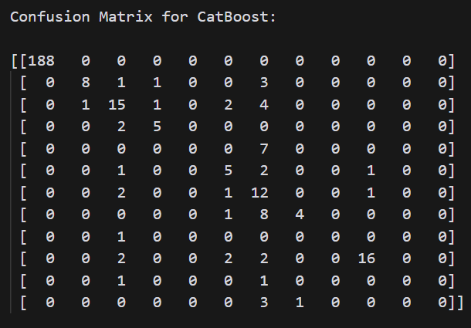

References:
- Improving ransomware detection based on portable executable header using exception convolutional neural networkCaio C. Moreira a, Davi C. Moreira, Claudomiro de S. de Sales Jr. https://www.sciencedirect.com/science/article/pii/S016740482300175X
- Zero-Ran Sniff: A zero-day ransomware early detection method based on zero-shot learning- https://www.sciencedirect.com/science/article/pii/S0167404824001500
- Ba’abbad, I.; Batarfi, O. Proactive Ransomware Detection Using Extremely Fast Decision Tree (EFDT) Algorithm: A Case Study. Computers 2023, 12, 121. https://doi.org/10.3390/computers12060121
- Nhlapo, Steven Jabulani, and Mike Nkongolo Wa Nkongolo. "Zero-day attack and ransomware detection." arXiv preprint arXiv:2408.05244 (2024).

